Resources

Banners and Posters for Colorectal Cancer Awareness Month
You can print from the online documents at:
http://www.screen4coloncancer.org/screeningOptions.asp

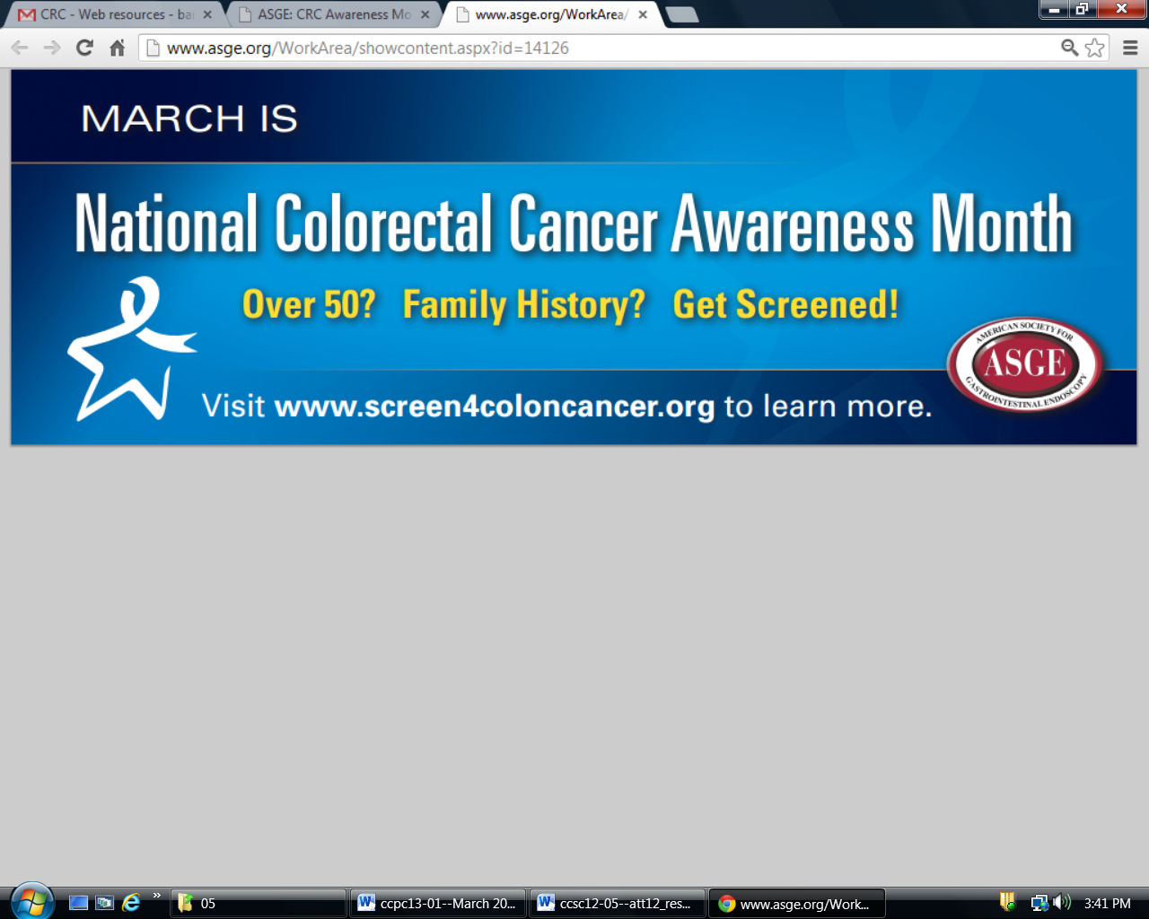

The Colon Cancer Puzzle: A video on the colorectal cancer screening
You can order a copy at no cost or view it online at: http://ecog.dfci.harvard.edu/general/videoinfo_col.html

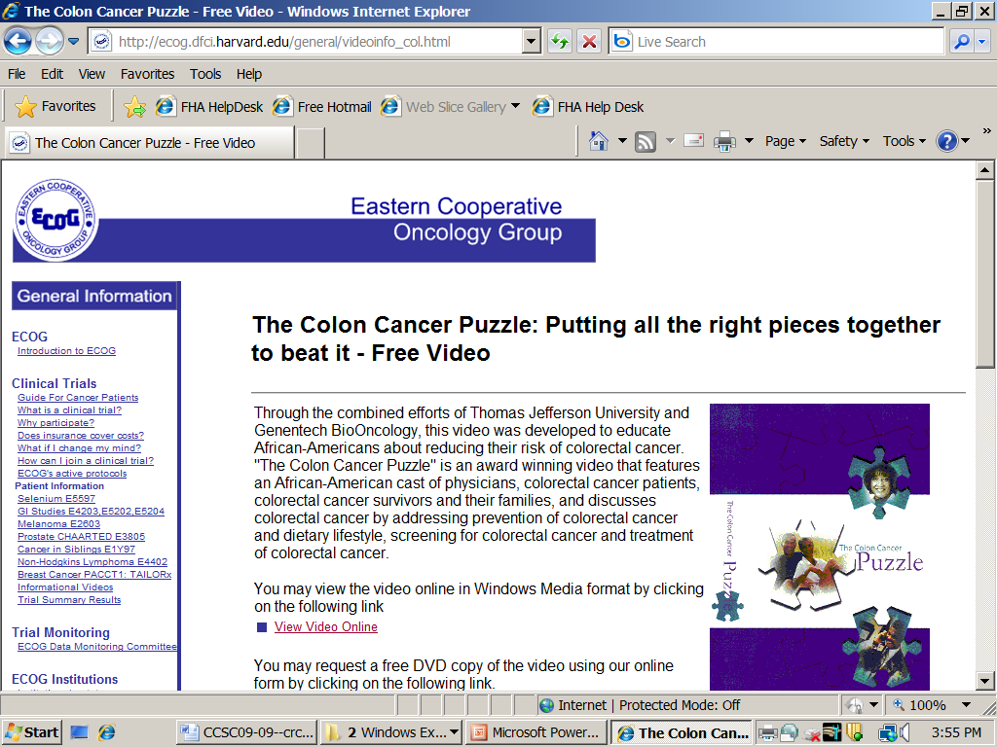

How to Increase Colorectal Cancer Screening in Practice: A Primary Care Clinician’s Evidence-Based Toolbox and Guide
http://nccrt.org/about/provider-education/crc-clinician-guide/
and
http://www.cancer.org/acs/groups/content/documents/document/acspc-024588.pdf

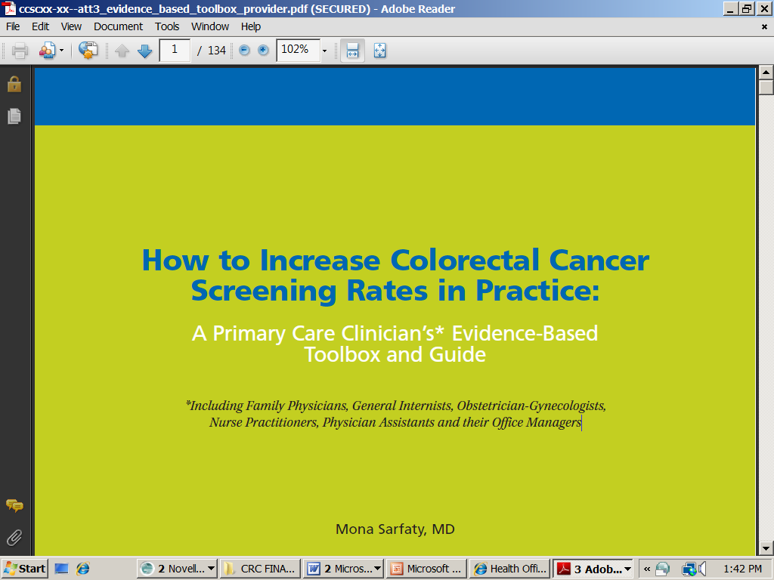

Family PLZ! Campaign
http://nccrt.org/about/public-education/family-plz/



